Bringing Smiles Through Food: A Journey with the ‘Tiffiner Hashi’ Project

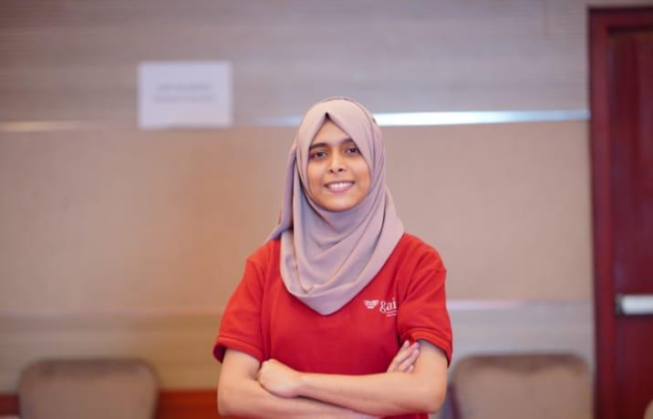

At Vidyasava School in Khulna, lunchtime often revealed a quiet truth. Some children brought colourful tiffin boxes filled with snacks, while others opened empty lids or avoided eating altogether. A few shared what they had, and many stayed silent. Watching these moments week after week made Sayeda think about how something as simple as tiffin time could reflect a much bigger reality.
Her interest in the issue deepened after she participated in the Food Systems Youth Leadership Training organized by GAIN and SUN Youth Network Bangladesh, with support from national partners. The training offered a clearer understanding of how food, equity and children’s wellbeing are connected.
“It did not just give us information about food systems,” she said. “It helped me understand how nutrition, fairness and learning come together. That connection made me pay closer attention to the children in my own community.”
After the training, Sayeda began visiting nearby schools including Vidyasava School and Balughat High School. She spoke with teachers, students and parents to learn more about their experiences. In many classrooms she found the same pattern. Some students wasted food, others skipped their tiffin entirely, and many felt embarrassed to admit they were hungry.
“One teacher told me that some students pretend not to be hungry to avoid embarrassment. Hearing that made the situation feel very real,” she said.

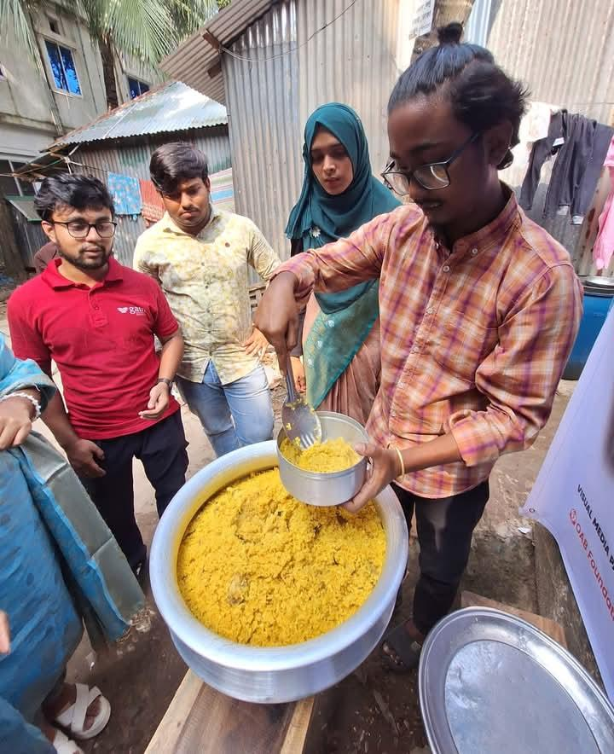

To respond to this, Sayeda created the Tiffiner Hashi project, an initiative focused on reducing food waste and making sure no child feels left out during tiffin time. She started small, with a youth team and a plan built around awareness and empathy.
Together they organized sessions on healthy tiffin choices, nutrition and hygiene. Posters and activities helped children learn in a simple and engaging way. They introduced a “Tiffin Bank,” a sharing model that allowed students to contribute or receive food discreetly. Games and conversations helped create comfort and reduce stigma.
Starting the project came with challenges. Funding was limited and some people doubted whether the idea would work. Still, Sayeda continued. Over time, the Ryan Foundation and Center for Aid partnered with her team and signed an MoU, providing fifteen thousand taka to support the work. That support helped them expand their activities and reach more students.
The impact soon became visible. Hundreds of students participated in the sessions, and teachers reported more conversations about healthy eating and sharing. One of the most meaningful changes for Sayeda came from a student who had once been quiet about her empty tiffin.
“The most meaningful moment for me is when a usually quiet student now participates in the Tiffin Bank. She accepts or shares food without hesitation. It is not just about the meal but the sense of inclusion she feels,” Sayeda said.

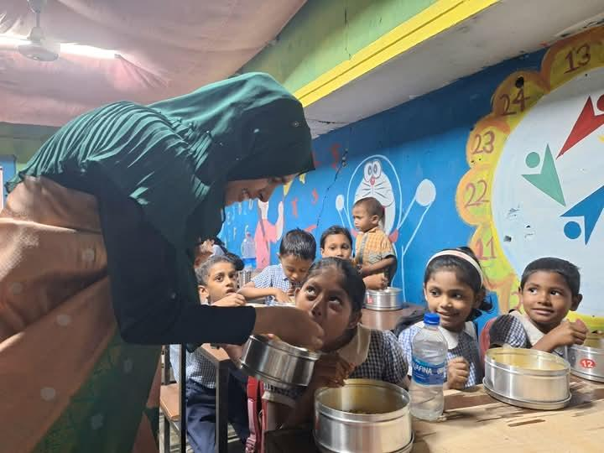

Students are also noticing the difference. Samira, a young student from Vidyasava School, shared, “Before Tiffiner Hashi, my tiffin box was often empty and I used to hide during break time. Now I always have something to eat with my friends, and I learned to draw my favourite healthy vegetables from the posters. I do not feel left out anymore.”
For Sayeda, the goal goes beyond tiffin. She hopes to expand Tiffiner Hashi to more schools, train more youth and encourage communities to view food not only as a meal but as a way to build belonging, confidence and care.

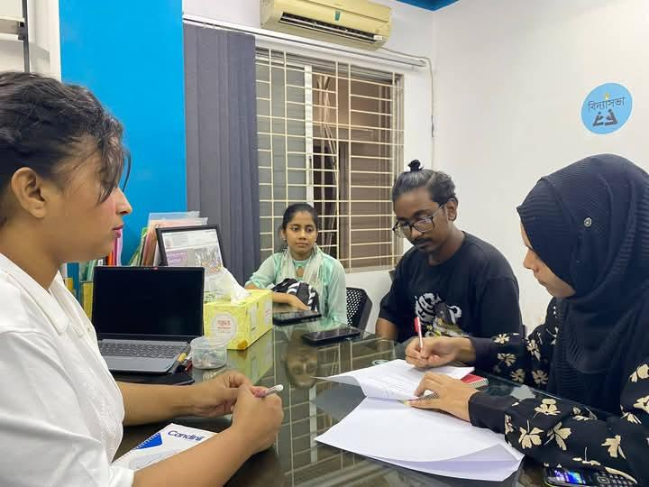

This project isn’t just about tiffin—it’s about awareness, sustainability, and care. As she moves forward, she plans to expand “Tiffiner Hashi” to more schools, train other youth, and strengthen the message that every child deserves healthy food and a happy break time.
The change is visible, and students like young Samira from Bidyasovha School feel it too. "Before 'Tiffiner Hashi,' my tiffin box was often empty, and I used to hide during break time. Now, because of the 'Tiffin Bank' Sayeda Apa started, I always have something to eat with my friends, and I’ve even learned to draw my favorite healthy vegetables from the posters! I don't feel left out anymore."

